MIN MAX ALGORITHM FOR GAMING

AIM: To implement a python program for Min Max Algorithm for gaming.

OBJECTIVES:
- To understand the concept of the Minimax Algorithm.
- To implement decision-making for a game-playing AI.
- To select the best possible move for the AI.
- To understand MAX and MIN players.
- To apply recursion for evaluating possible game states.
ALGORITHM:
- Start with the current game state.
- Check whether the game has reached a terminal state.
- If the game is over, return its score.
- If it is the MAX player's turn, find the maximum score among possible moves.
- If it is the MIN player's turn, find the minimum score among possible moves.
- Recursively evaluate all possible moves.
- Select the move having the best score for the AI.
- Display the best move and its score.
SYSTEM-ARCHITECTURE:
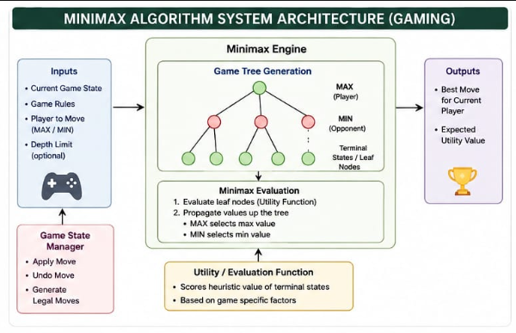

PROGRAM:
def minimax(depth, is_max):
if depth == 0:
return 0

if is_max:
best = -999
for move in [1, 2]:
score = minimax(depth - 1, False) + move
best = max(best, score)
return best
else:
best = 999
for move in [1, 2]:
score = minimax(depth - 1, True) - move
best = min(best, score)
return best

print("Best Score:", minimax(3, True))

OUTPUT:
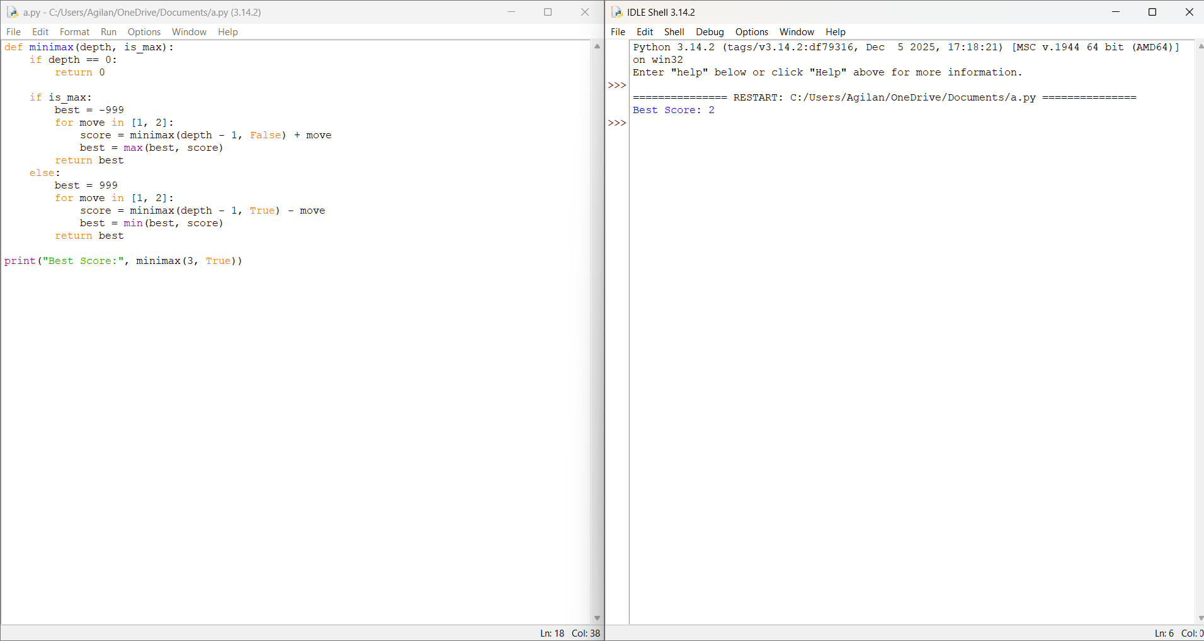

RESULT: Thus the Min Max Algorithm for gaming is implemented successfully using python language.

